Chapter 15, Solution 3.

- 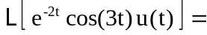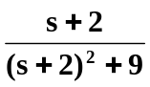

- 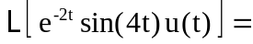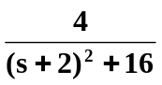

- Since 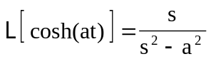
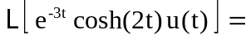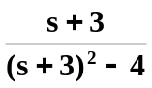

- Since 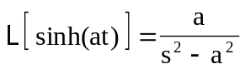
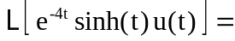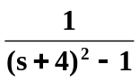

- 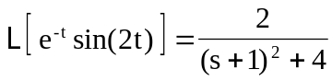

If 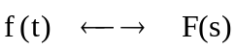
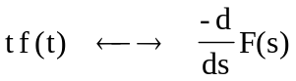
Thus, 